**Phone :** +998-90-001-06-95, **|** **Email :** islomjonergasheveie@mail.ru,

**Address :** Jambul 1st avenue, 1, Tashkent, Uzbekistan

**Islomjon Ergashev**

WORK EXPERIENCE

*Sales Manager*

*OOO PRIMELINECOMMUNICATION | Tashkent, Uzbekistan*

**Custumer Service Operator**

**OOO UNITEL | Tashkent, Uzbekistan**

JULY 2019 – CURRENT

* Consulting clients
* Dealing with complaints

ABOUT ME

I am a 25 years old, birth date 29.06.1995. I have experience in packet tracing, marketing, dealing with clients, leadership and communication skills. I am honest, empathetic, just, responsible, punctilious. I have healthy lifestyle. I passionate about IT.

REFERENCES

EDUCATION

*08.02.2020*

RESUME

**Bachelor in Mobile Systems**

*Telecommunication technologies Tashkent University of Information technologies named after al-Khwarismi, Tashkent, Uzbekistan*

Sep 2016 - June 2020

**Islomjon Ergashev**

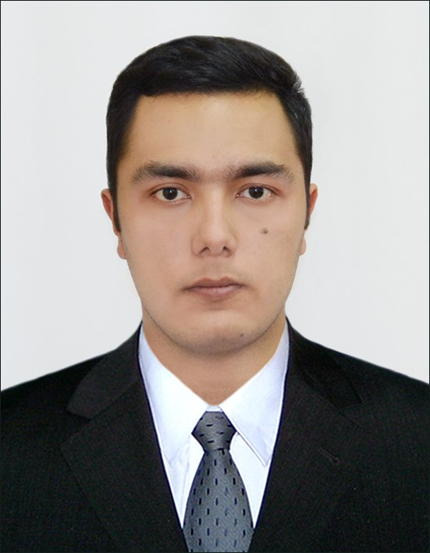

* Telecommunication: GSM, model OSI
* Computer Literacy
* English proficiency
* Russian proficiency
* Uzbek proficiency
* Photoshop

**Tlg:** @Svyazsvyaz_38

**Insta: islomjon_eie_svyaz_38**

**E:** islomjonergasheveie@mail.ru

**P:** +998-90-001-06-95

* Product consulting
* Marketing
* Dealing with complaints

AUGUST 2017 – APRIL 2018

SKILLS